#### Data Wrangling:

(See /data/ folder for .R files).

From Census microdata we list anyone who identifies as Hispanic as an ethnicity as Hispanic, regardless of race, and combine other and 2+ races as “other”, we do not display the other or 2+ race categories in our visualization. Then, from the microdata, the percentage of each racial category by state is calculated with a weighted percentage function. From the CDC BRFSS Survey data, the percentage of each racial category with preexisting conditions is similarly calculated (except for “senior”, which is also calculated using Census Microdata). The preexisting conditions ratio is calculated by dividing the percentage of the state population of each preexisting condition by the percentage of the total state population (any number greater than one signifies that race disproprotionately has that preexisting condition).

From the Census American Community Survey (ACS) state level data, we isolated estimates for counts of all people who identify as the following race/ethnicity (RE) groups (including those who classify themselves under two or more races): American Indian or Alaska Native (AIAN), Asian, Black, Hispanic, Native Hawaiian or Pacific Islander (NHPI), and White. The estimated counts for each RE group were then divided by the state population to calculate the percent population for each RE group in each state. These RE percentages total to over 100% due to overlap. From the Racial Data Tracker Dataset, we then isolated the COVID-19 case and death counts for each state as well as their RE breakdowns. The state-level case/death counts for the RE groups isolated from the ACS data were divided by the total state case/death counts and scaled to calculate percent of cases/deaths for each state that belong to the specified RE groups. The percent cases/deaths for each state and RE group were then divided by the state population percentages for each RE group from the ACS data to obtain the case/death ratios used to determine disproportionation of COVID-19 to different racial/ethnic groups.

#### Interpretation:

Racial and ethnic minorities are facing disproportionate cases and deaths due to COVID-19. However, there are inconsistencies in state COVID-19 reporting, such as the multitude of cases with unknown racial/ethnic classification and differences in racial categorization schemes, along with inconsistencies in the beta-released Racial Data Tracker. These inconsistencies make it difficult to make strong claims about effects on specific communities (primarily the American Indian/Alaska Native and Native Hawaiian/Pacific Islander communities). As we continue to fight this pandemic, Congress must demand that states consistently report COVID-19 demographic data.

There are a wide range of outcomes for preexisting conditions between states. For states attempting to prevent COVID-19 or future pandemics from taking a heavier toll on vulnerable communities, they must address the inequitable social structures that lead to imbalanced health outcomes within their states. This cannot be a one size fits all model as each state combats different health disparities.

#### 

#### Write something saying that missing data does not indicate a lack of deaths/cases but rather incomplete data.

#### 

#### Situation Tab

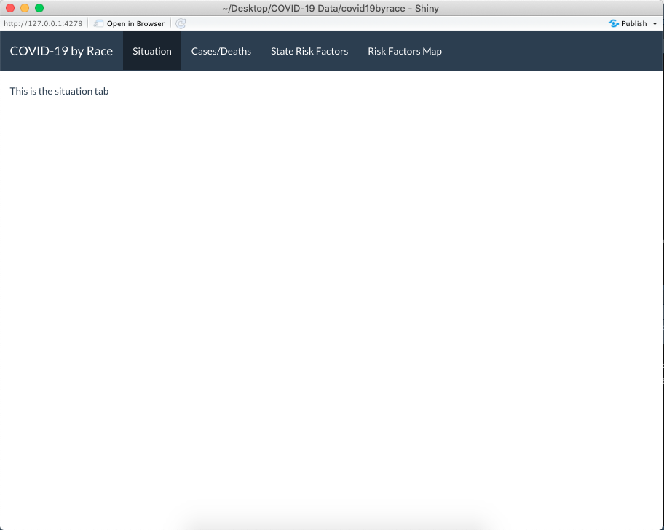

Under normal circumstances, the typical cruelty of the deep inequities of American society is seen as a long-term problem that may be dealt with under the next administration. However, as COVID-19 has spread, it has not spread amongst the population evenly. These pre-existing inequalities have given rise to a distinct impact in COVID-19 cases and deaths on racial minorities. In order to prevent future pandemics from wreaking disparate havoc on Black, Hispanic, and Native American communities, policy makers must tackle the systemic poverty, lack of healthcare, and food poverty from which these disparities arise.

This project attempts to map where COVID-19 related cases and deaths have hit underserved minority communities particularly hard while showing where preexisting conditions for those communities have been allowed to grow. Hopefully, mapping these inequalities will allow policy makers to build a more paritable society.

#### Cases/Deaths Tab:

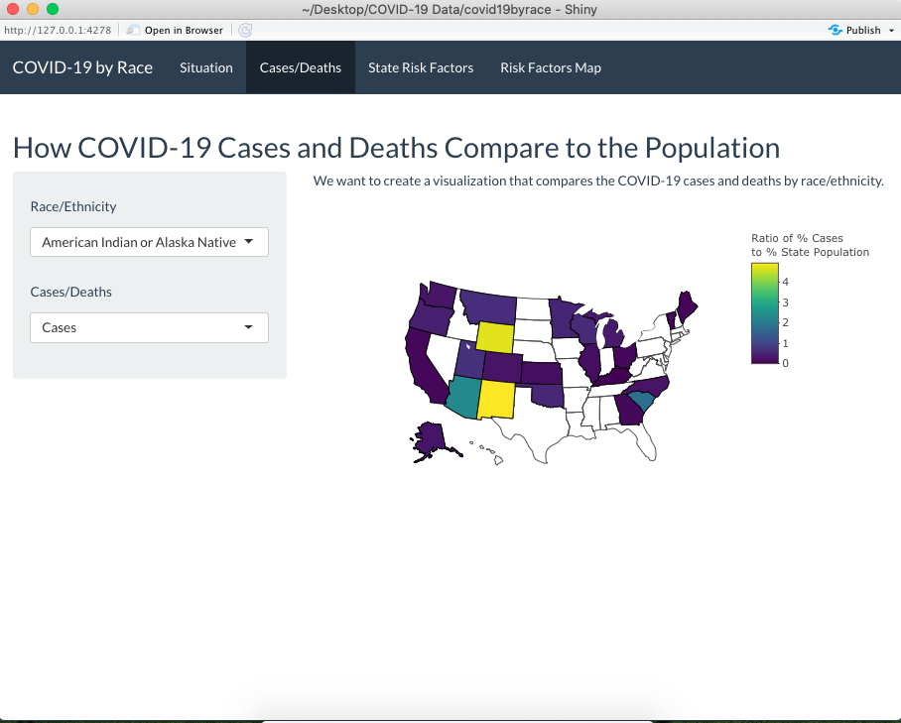

The map below serves to display

Notes:

1. Sources: Census American Community Survey 2018 5-Year Estimates , The COVID Tracking Project ([Racial Data Tracker Dataset](https://covidtracking.com/race))
2. The ratio shown in the map is the percent of the cases or deaths of the selected race divided by the percent of the population of the race. For example, the cases ratio in Alabama under white is the percent of COVID-19 cases that have been identified as white divided by the percent of the population that identifies as white.
3. The percent populations of a particular race/ethnicity category for each state are calculated from the percent of all people in each state who fit that particular race/ethnicity category. For example, the percent white in Alabama is calculated as the percentage of the people in Alabama who would be able to categorize themselves as white (including people with two or more races). So all ratios displayed on the above map are underestimates.
4. Missing case/death data may be a result of inconsistencies in state reporting as opposed to a lack of cases/deaths for a particular race/ethnicity.
5. COVID-19 case and death data is as current as **April 29, 2020**.

#### Risk Factors Bar Graph Tab:

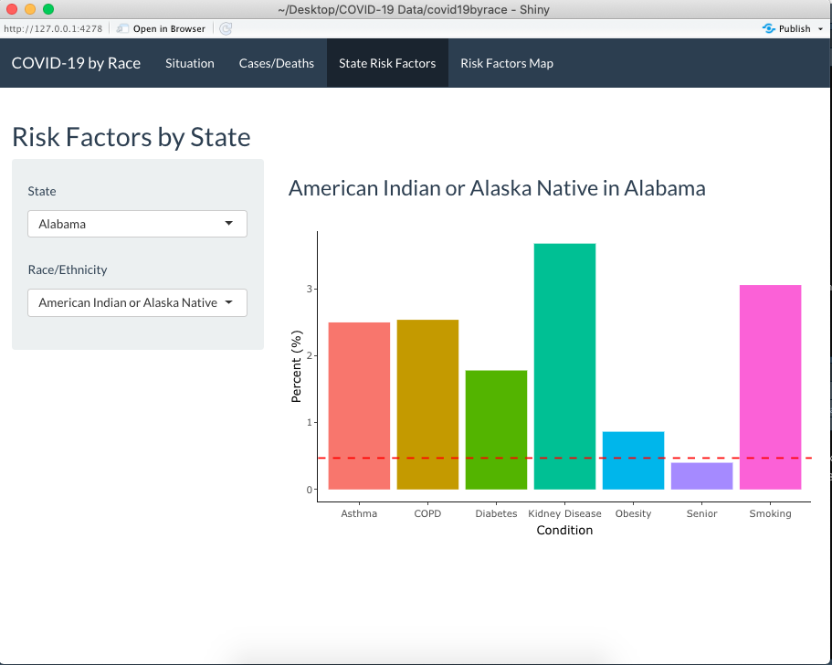

Race percent of condition

1. Sources: Census American Community Survey 2018 5-Year Estimates via IPUMS, 2018 CDC Behavioral Risk Factor Surveillance System Survey
2. The percent population by race and condition is the percent of the population with the condition that is that race, for example, the “percent white in Alabama with asthma” is calculated as the percentage of the people in Alabama with asthma who categorize themselves as white
3. The red line through the bar graph shows the race/ethnicity’s percent of the population

#### Risk Factors Map Tab:

Put stuff to say in the risk factors tab 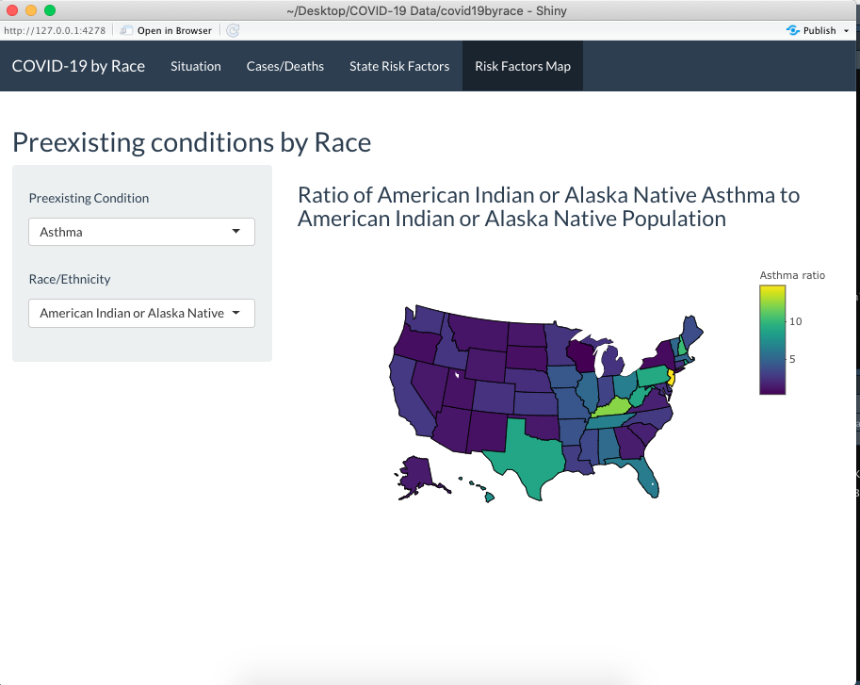here

Notes

1. Sources: Census American Community Survey 2018 5-Year Estimates via IPUMS, 2018 CDC Behavioral Risk Factor Surveillance System Survey
2. The mapped ratio is the percent of the selected condition of the selected race divided by the percent of the population of the race. For example, the white asthma ratio in Alabama is the percent of Alabamians with asthma that identify as white divided by the percent of the population that identifies as white

Sources:

Census American Community Survey 2018 5-Year Estimates (<https://data.census.gov/cedsci/>)

Census American Community Survey 2018 5-Year Estimates via IPUMS

The COVID Tracking Project - Racial Data Tracker Dataset (<https://covidtracking.com/race>)

CDC Behavioral Risk Factor Surveillance System Survey 2018 (<https://www.cdc.gov/brfss/annual_data/annual_2018.html>)